MARBLEHEAD TROPHY
VILAMOURA - PORTUGAL
28th – 31st October 2020
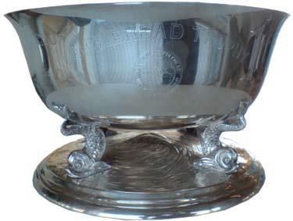

The below mentioned Yacht Club hereby challenges The Yacht Harbour “Hercules” for Marblehead Trophy 2020

Name of the challenging Yacht Club:

Dragon representing the challenging Yacht Club:

Sail Number Yacht name Skipper

email contact phone nr

Date, name and signature of the Yacht Club representative forwarding the challenge:

Date Name Position Signature Yacht Club Stamp

This form to be sent to: algarvedragonwintercup@prowgroup.com
Upon receipt of form challenging skipper will be contacted by Organizers to complete entry

